# DAD 220 Database Documentation Tyler Cornell

## Step One: Create a Database

1. Navigate to your online integrated development environment (IDE). Here, you will need to write the proper SQL commands in command line to create tables that demonstrate relationships based on the entity relationship diagram. List and record the SQL commands that you used to complete this step here:

I constructed the database and subsequently listed all databases to confirm the setup. Following that, I established a connection to the newly created database.

1. Create a database schema called *QuantigrationUpdates*. List out the database name. Provide the SQL commands you ran against MySQL to successfully complete this in your answer:

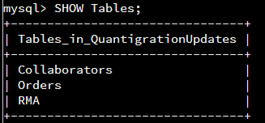

The database was created from the previous step and the tables that created within it were from the following steps.

1. Using the ERD as a reference, **create the following tables with the appropriate attributes and keys**:
   1. A table named **customers** in the *QuantigrationUpdates* database as defined on the project ERD. Provide the SQL commands you ran against MySQL to complete this successfully in your answer:

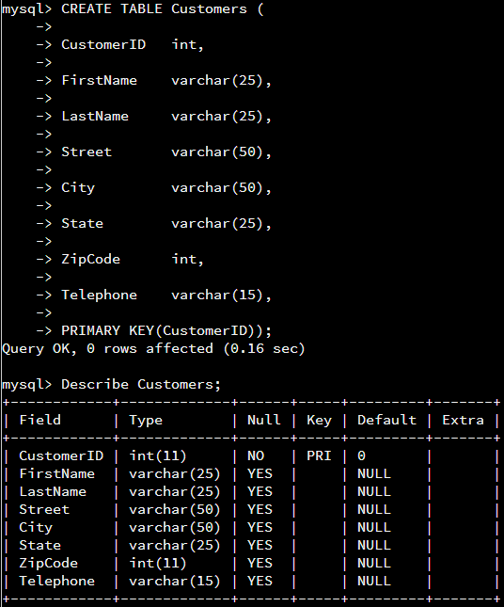

I set up the table using the specifications outlined in the diagram, and designated `CustomerID` as the primary key. To confirm the setup, I executed a command to describe the table's structure.

* 1. A table named **orders** in the *QuantigrationUpdates* database as defined on the project ERD. Provide the SQL commands you ran against MySQL to complete this successfully in your answer:

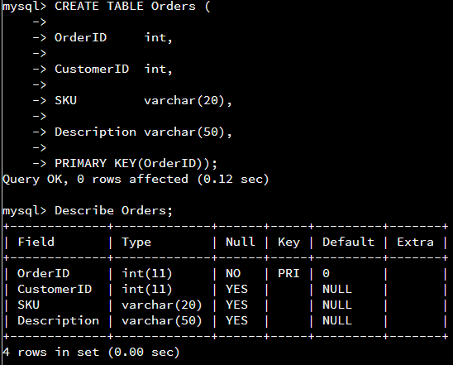

I constructed the table according to the details provided in the diagram, setting `OrderID` as the primary key. To verify the setup, I used the `DESCRIBE` command to review the table's configuration.

* 1. A table named **rma** in the *QuantigrationUpdates* database as defined on the project ERD. Provide the SQL commands you ran against MySQL to complete this successfully in your answer:

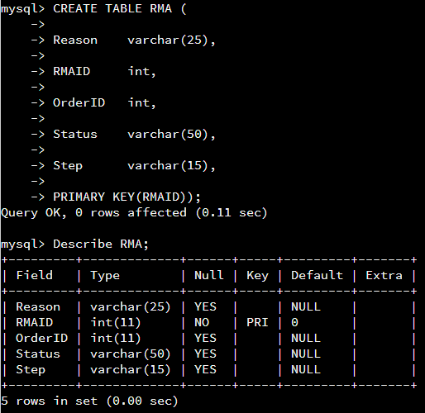

I set up the table following the specifications in the diagram, designating `RMAID` as the primary key. To confirm the table's structure, I used the `DESCRIBE` command.

1. **Update your existing table** from “Customer” to “Collaborator” using SQL based on this change in requirements. Provide the SQL commands you ran against MySQL to complete this successfully in your answer:

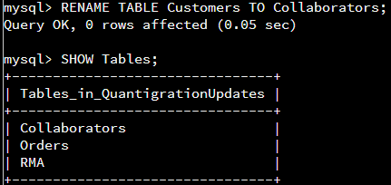

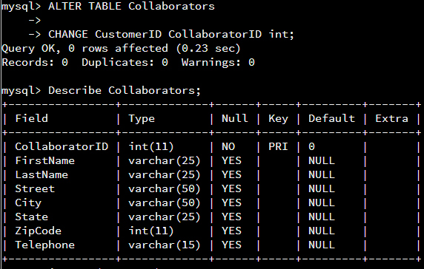

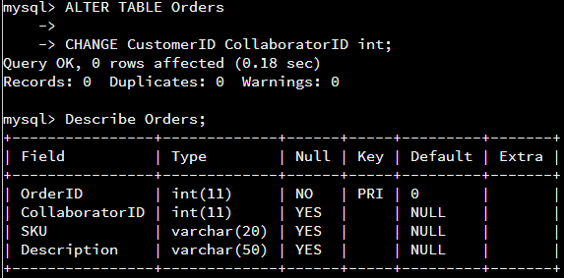

All instances of customer were changed to collaborator due to the new company branding initiative.

## Step Two: Load and Query the Data

1. **Import the data from each file into tables**.
   * Use the *QuantigrationUpdates* database, the three tables you created, and the three CSV files preloaded into Codio.
   * Use the import utility of your database program to load the data from each file into the table of the same name. You will perform this step three times, once for each table.

LOAD DATA INFILE "/home/codio/workspace/customers.csv" INTO TABLE Collaborators

FIELDS TERMINATED BY ','

LINES TERMINATED BY '\n'

(CollaboratorID,FirstName,LastName,Street,City,State,ZipCode,Telephone);

LOAD DATA INFILE "/home/codio/workspace/orders.csv" INTO TABLE Orders

FIELDS TERMINATED BY ','

LINES TERMINATED BY '\n'

(OrderID,CollaboratorID,SKU,Description);

LOAD DATA INFILE "/home/codio/workspace/rma.csv" INTO TABLE RMA

FIELDS TERMINATED BY ','

LINES TERMINATED BY '\r\n'

(RMAID,OrderID,Step,Status,Reason);

1. **Write basic queries against imported tables to organize and analyze targeted data.** For each query, replace the bracketed text with a screenshot of the query and its output. You should also include a brief, 1- to 3-sentence description of the output.
   * Write an SQL query that returns the count of orders for customers located only in the city of Framingham, Massachusetts.
     1. How many records were returned?

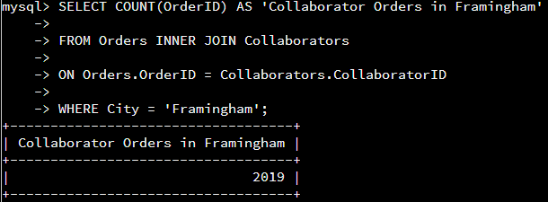

There are 2019 collaborator orders where the collaborator resides in the city of Framingham.

* + Write an SQL query to select all of the customers located in the state of Massachusetts.
    1. Use a WHERE clause to limit the number of records in the customers table to only those who are located in Massachusetts.

SELECT * FROM Collaborators WHERE State = 'Massachusetts';

* + 1. Record an answer to the following question: How many records were returned?



There were 4004 rows returned when running a query for customers residing in Massachusetts.

* + Write a SQL query to insert four new records into the orders and customers tables using the following data:
    1. Customers Table

| **CustomerID** | **FirstName** | **LastName** | **StreetAddress** | **City** | **State** | **ZipCode** | **Telephone** |
| --- | --- | --- | --- | --- | --- | --- | --- |
| 100004 | Luke | Skywalker | 15 Maiden Lane | New York | NY | 10222 | 212-555-1234 |
| 100005 | Winston | Smith | 123 Sycamore Street | Greensboro | NC | 27401 | 919-555-6623 |
| 100006 | MaryAnne | Jenkins | 1 Coconut Way | Jupiter | FL | 33458 | 321-555-8907 |
| 100007 | Janet | Williams | 55 Redondo Beach Blvd | Torrence | CA | 90501 | 310-555-5678 |

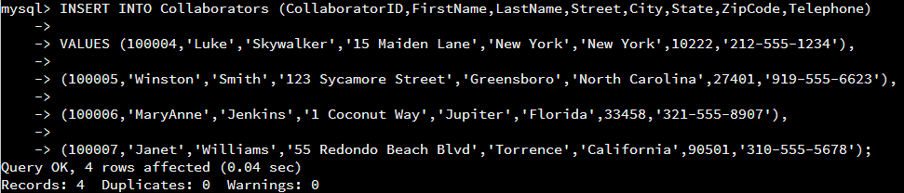

I used an insert statement and specified the order of the values being added. I then wrote those values in the order I specified to insert them into the correct columns.

* + 1. Orders Table

| **OrderID** | **CustomerID** | **SKU** | **Description** |
| --- | --- | --- | --- |
| 1204305 | 100004 | ADV-24-10C | Advanced Switch 10GigE Copper 24 port |
| 1204306 | 100005 | ADV-48-10F | Advanced Switch 10 GigE Copper/Fiber 44 port copper 4 port fiber |
| 1204307 | 100006 | ENT-24-10F | Enterprise Switch 10GigE SFP+ 24 Port |
| 1204308 | 100007 | ENT-48-10F | Enterprise Switch 10GigE SFP+ 48 port |

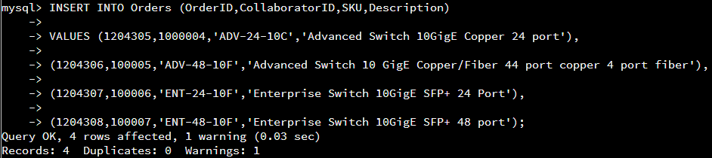

I used an insert statement and specified the order of the values being added. I then wrote those values in the order I specified to insert them into the correct columns.

* + In the customers table, perform a query to count all records where the city is Woonsocket, Massachusetts.
    1. How many records are in the customers table where the field “city” equals “Woonsocket”?





Woonsocket is in Rhode Island not Massachusetts. There are 26 customers residing in Woonsocket, RI. If you were to run it against MA, the rows populated would be 0.

* + In the rma database, update a customer’s records.
    1. Write an SQL statement to select the current fields of *status* and *step* for the record in the *rma* table with an *orderid* value of “5175.”
       1. What are the current status and step?

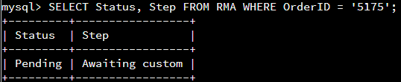

The current status of order 5175 is ‘pending’ and the step is ‘awaiting custom’.

* + 1. Write an SQL statement to update the *status* and *step* for the *orderid*, 5175 to *status* = “Complete” and *step* = “Credit Customer Account.”
       1. What are the updated *status* and *step* values for this record?

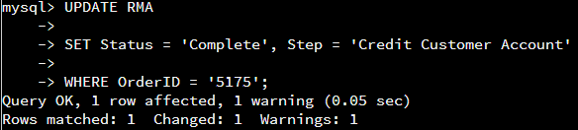

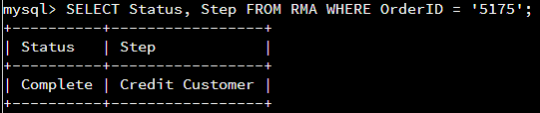

The updated status is Complete and the updated Step is Credit Customer.

* + Delete rma records.
    1. Write an SQL statement to delete all records with a reason of “Rejected.”
       1. How many records were deleted?

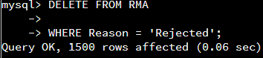

There were 1500 records that were rejected; therefore 1500 records were deleted.

1. **Create an output file of the required query results.** Write an SQL statement to list the contents of the *orders* table and send the output to a file that has a .csv extension.





I selected all the contents of the Orders table and outputted it to a .csv file. Since a .csv called orders and neworders already exists and won’t be overwritten, I named it neworders2.csv.